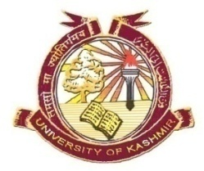**P.G. DEPARTMENT OF BOTANY, UNIVERSITY OF KASHMIR**

**SRINAGAR**

It is for the information of all the candidates registered for OE and GE courses of Semester Ist (2017 Autumn) in the Department of Botany that their theory Examination (End of Semester) of the GE / OE Courses shall be held as per the following date sheet in the Department of Botany.

**M.A/M. Sc. Ist Semester 2017 Autumn (2017- batch)**

|  |  |  |  |  |
| --- | --- | --- | --- | --- |
| **Basket** | **Date (Day)** | **Course** | **Subject** | **Time** |
| 1. Basket - IV | 02.03.2018 (Friday) | BOT17001GE  BOT17001OE | Principles of Genetics  Biogeography | 2.00 p.m |
| 1. Basket – V | 03.03.2018 (Saturday) | BOT17002GE | Urban Ecology | 2.00 p.m |

**Head**

**Department of Botany**

**No.F(M.A/M Sc. Ist Sem (OE / GE) exam)Bot/KU/18**

**Dated: 22.02.2018**

Copy for information to:

1. All the faculty members of the Department.
2. Notice Board.
3. File.